|  |  |
| --- | --- |
|  |  |
| LPL Website |  |
|  |  |
|  | 24.10.2020 |
|  | Satriaana |

**Introduction**

This is a prototype website for Lankan Premier League 2020. We developed this website as a single page website, rather than going to a multipage website. One reason is that it doesn’t take much time to load a single page compared to multiple pages.

**Home page/Landing page**

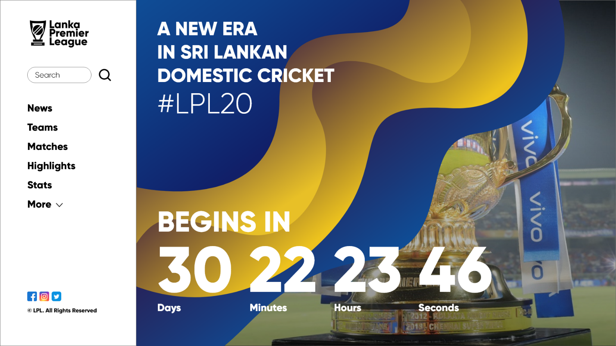

We used Blue and Yellow as our theme because they are the Sri Lankan Cricket Team colors along with a slight insight of the Trophy. We wanted to highlight blue and yellow that because this league is organized by the Sri Lankan Cricket Council. And we used black in the white background for the left panel in order to give out UI a clean look/appearance.

**News**

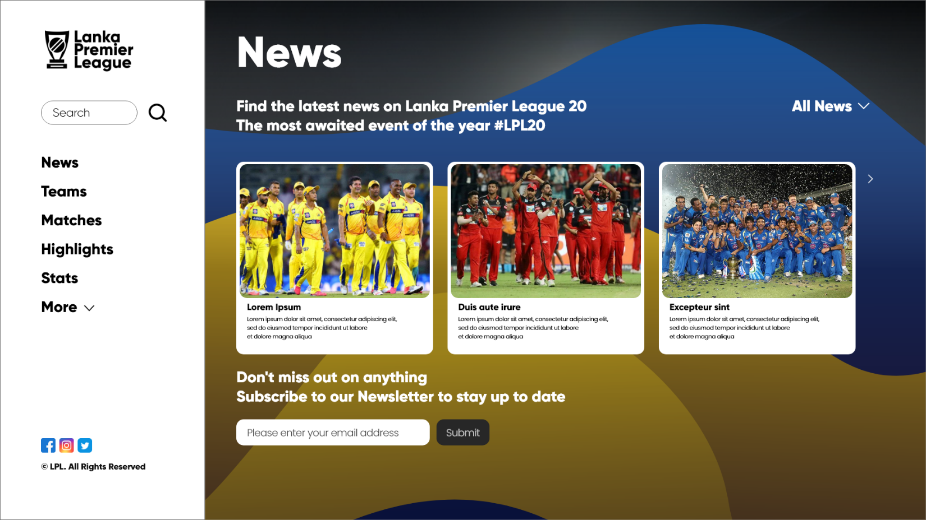

We used the same theme colors for this page also, along with black to contrast with the left menu panel. We used curve edged boxes because of the consistency of the UX, so whenever the user needs to find out anything, it is easy.

**Matches**

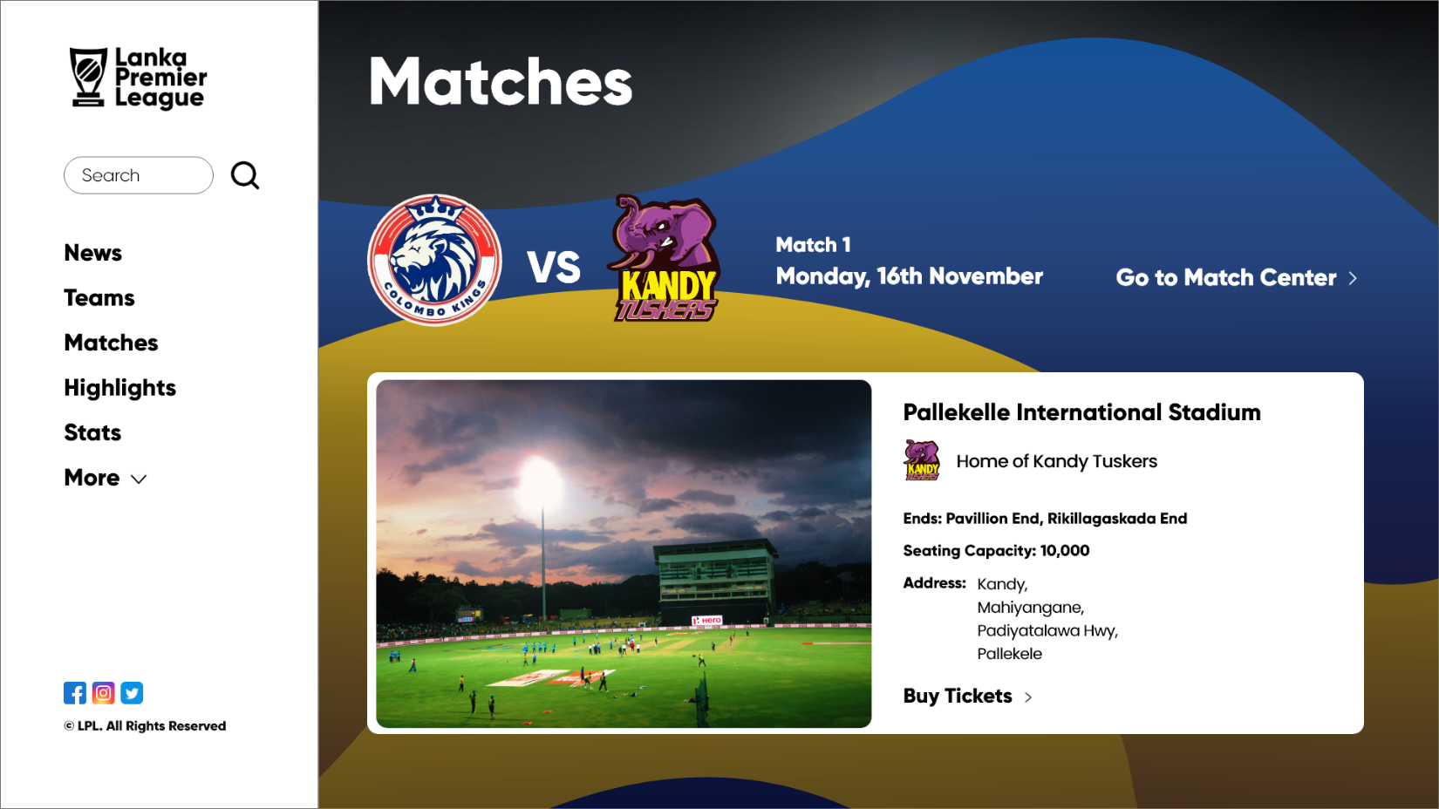

**Highlights**

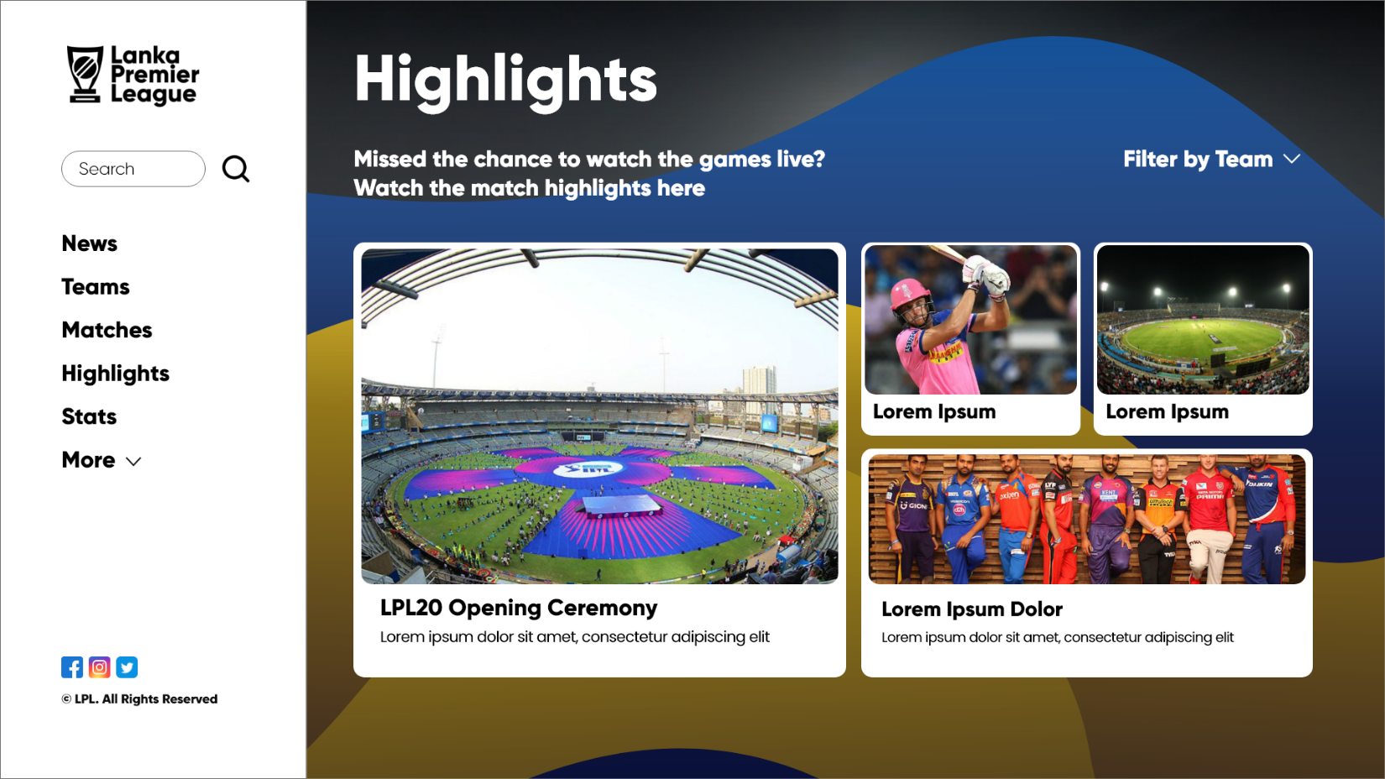

**Stats**

